# Preparation for Git Team Lab

This lab are a mishmash of steps that need to be completed individually before we meet again in class.

## Step-1

Signup for a github account.

Easiest way to do this is by going here:

**http://education.github.com/pack**

If you already have a github account, you can still get the pack (and you should!), but you can also just go to the next step. Some of these are just awesome technologies that might be of use later when you are writing programs to take over the world. One thing you’ll need to do for certain is to verify your email address. You can check to see if your email is verified by going to the github settings clicking on the icon on the upper right, going to *Settings*, and then clicking on *Emails* in the Personal Settings list on the left. The other thing you should do is give youself an icon, it can be the same one as from basecamp if you’d like. You can also change this in settings.

## Step-2

Visit this URL:

**http://j.mp/55gitprelab**

Make sure to accept any of the authorizations that are present and to Accept the assignment. This is going to have you enter the comp55 organization. If you have already signed up for an account it may ask you to re-enter your credentials. Once you have clicked on all the admin processes and you’ve reached the place where you get the message below (with your github username down below), you can move on to the next step. Leave this window open as we’ll need to access it later.

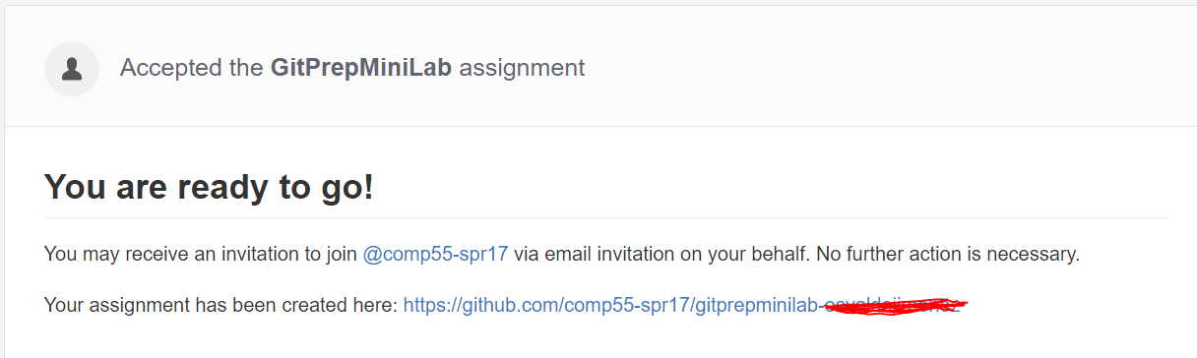

Make sure to save this URL that was just created specifically for you. You will need it for Step 8.

## Step-3

Now we are going to follow the rules that I adapted from this crunchify site (http://crunchify.com/how-to-configure-bitbucket-git-repository-in-you-eclipse/), however, I had to modify their directions so that they would work for GitHub instead of the site they used (bitbucket).

Now let’s make Eclipse ready for Git.

* Open Eclipse
* Click on Help menu
* Click Install New Software

[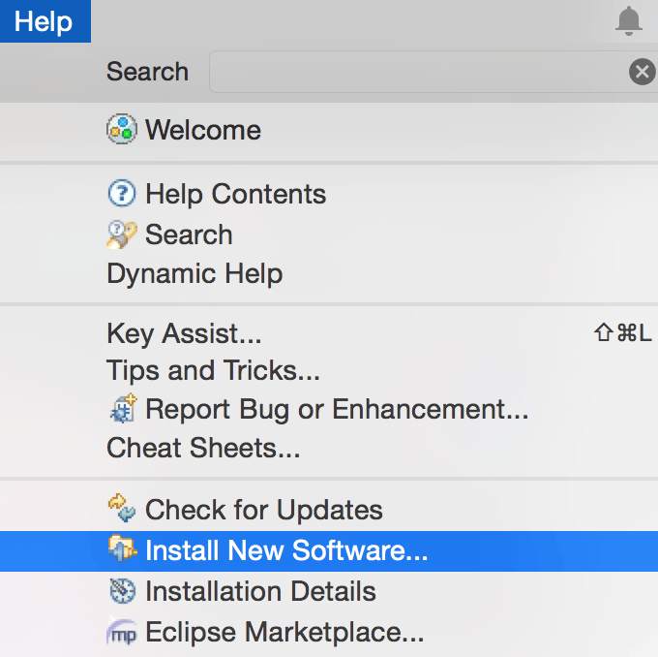](http://cdn.crunchify.com/wp-content/uploads/2013/05/Eclipse-Install-New-Software1.png)

## Step-4

Let’s Install eGit into [Eclipse](http://crunchify.com/step-by-step-guide-to-setup-and-install-apache-tomcat-server-in-eclipse-development-environment-ide/).

Click the Add Button in the upper right of the Install Window to add a repository

URL: http://download.eclipse.org/egit/updates

[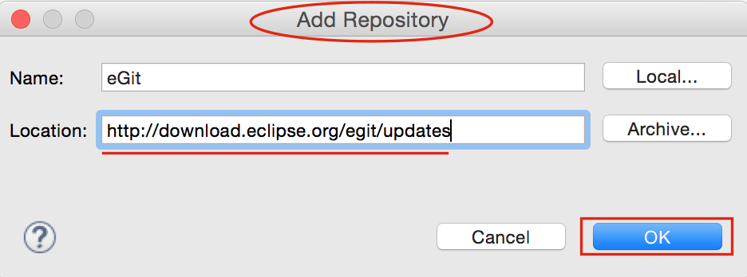](http://cdn.crunchify.com/wp-content/uploads/2013/05/Eclipse-Add-Repository.png)

## Step-5

Select Eclipse Git (1st option) and Java Implementation of Git (3rd option) form option and click next a few times accept the agreement and finish the install.

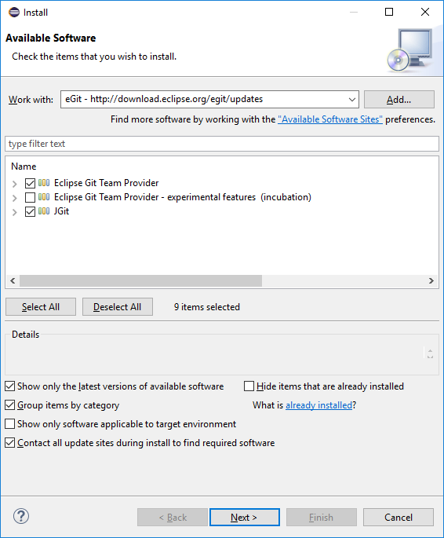

## Step-6

After it finishes, restart eclipse. Once eclipse restarts, Click Window -> Perspective -> Open Perspective -> Other and then choose Git from list and click OK. The other option is to click the highlighted button below which is in the toolbar in the upper right.

[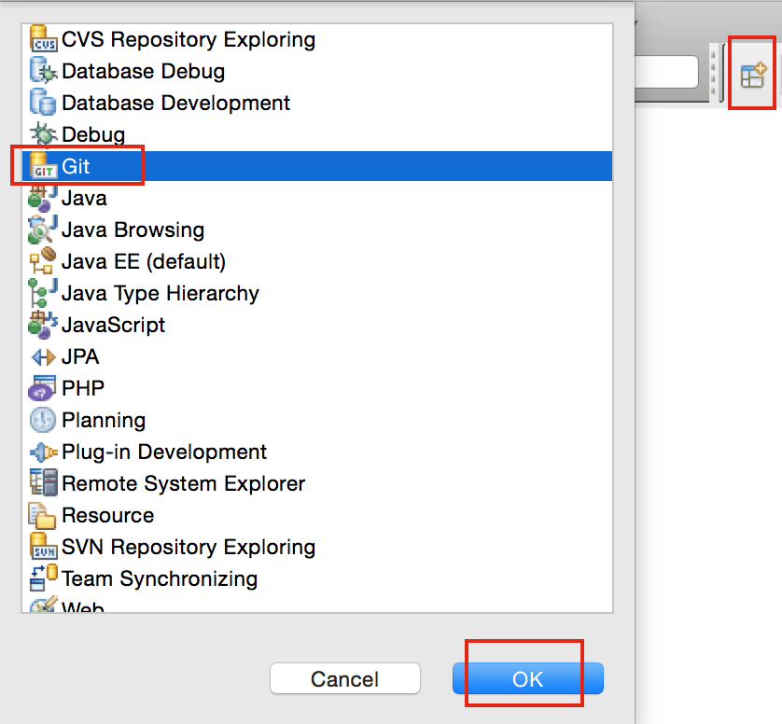](http://cdn.crunchify.com/wp-content/uploads/2013/05/Eclipse-Git-Prospective.png)

## Step-7

Click Clone Repository [Button](http://crunchify.com/simple-scroll-to-top-button-in-wordpress-footer-without-any-javascript-loading-genesis-framework-tips/).

[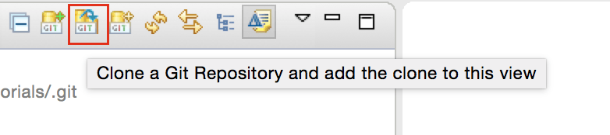](http://cdn.crunchify.com/wp-content/uploads/2013/05/Clone-Git-Repository-to-Eclipse-and-Add-to-View.png)

## Step-8

Enter your GitHub URL that you were given for this prelab assignment from Step 2. Not sure what this is? You can go back to the page I asked you to leave open on Step 2 and click on the link that discusses your assignment (*KEEP SCROLLING to see the picture*). When you get there, or if you log back in you just need to access your repositories, which will be listed on the right once you login to github. Once you click on that repository, you’ll eventually see a page like this:

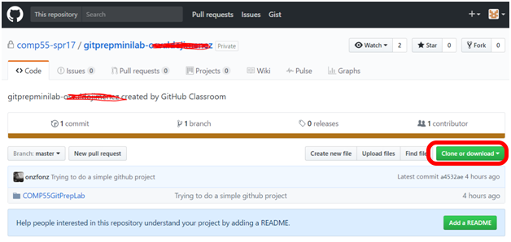

Click the Green button that says *“Clone or Download”* and then click this button (the clipboard icon to the right of the URL) to get automatically copy that URL to your clipboard. Once you do this it may actually automatically paste the URL into eclipse for you. Also check the option Store in Secure Store so that way your password is saved. As part of this, it might ask you for some recovery questions, which you can provide if you want.

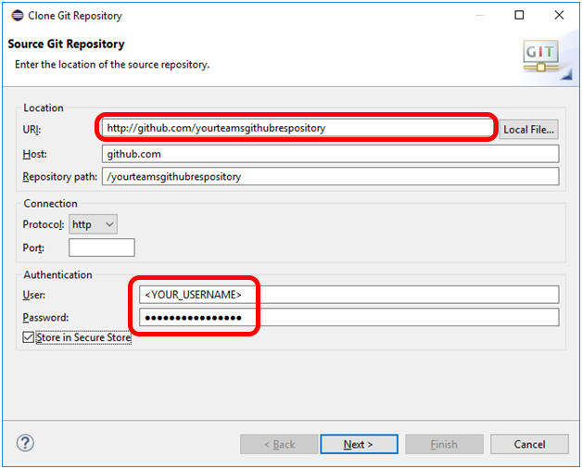

Click Next, which will bring you to a branch selection window, which you can just click Next again. This will lead you to this Local Destination Window, which looks like this:

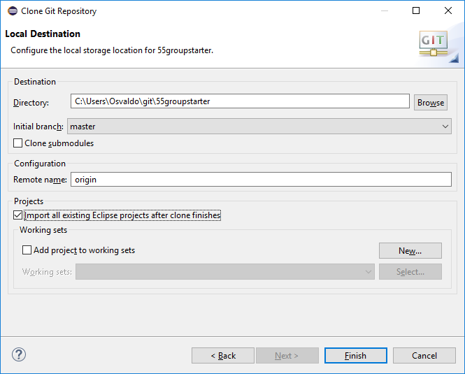

Make the option Import all existing Eclipse projects after the clones finishes is selected and then click Finish

## Step-9

You should see your GitHub repository now in eclipse’s Git Repositories window. This is part of the Git View.

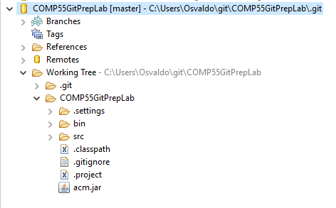

## Step-10 – Running the downloaded project

Now you can switch back to the Java Perspective which is the little toolbar button with the ***J*** that is in the upper right



You should now see your java project, but it will look slightly differently. Because the project is connected to the repository now you’re going to see the project name followed by some brackets and the repository name.

Go ahead and open up the project *COMP55GitPrepLab* and double click on *SimplePicture.java* . You’ll see that it will behave like if you imported the project. You can also run it if you like by running simple picture. At this point the project should work and run. If it doesn’t, you may have to change some preferences on your eclipse, but this is very rare.

# Step-11 Editing your Git Preferences

So that we can make sure that you get credit for committing and working on the project, we’re going to have you make one additional change to your Eclipse settings, which you should also do if you work on any other computers so that you get credit for all the work that you do. In order to do this, we’ll go into eclipse and click on *Window->Preferences* (If you are on a mac, this would be in *Eclipse->Preferences*.

Once there, you’ll see a window like this.

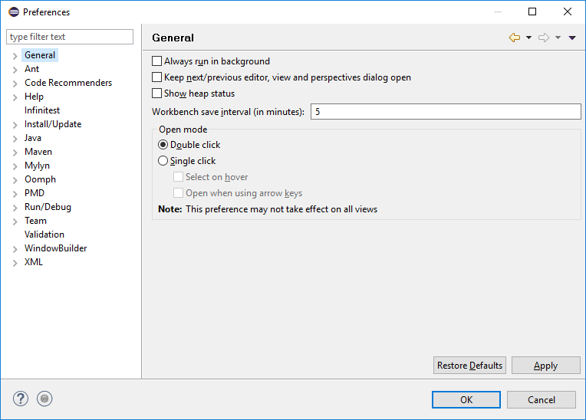

In the left hand menu, you can click the down arrow for *Team* and then click *Git*, alternatively, you can just search for **Git** in the filter text box in the upper left, and then click on the *Git* label. Once you click on the Git label’s down arrow, you should click on *Configuration*, which would get you to this window.

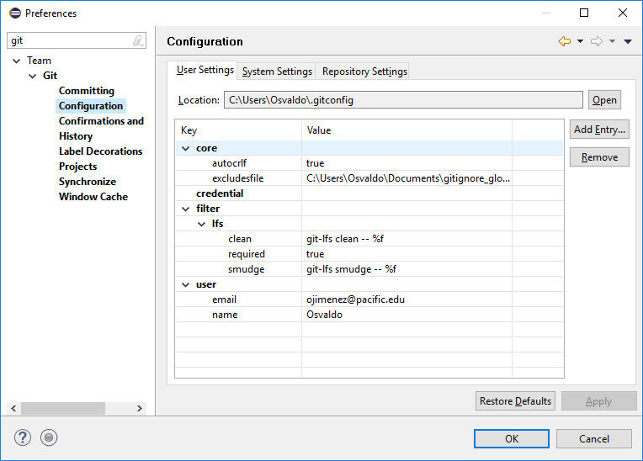

The trick is that you want your user entry and email to be in there, so you can add those entries by using the email you used to signup for github. If you notice, you won’t see an email field in your user settings, so click on user and then click the *Add Entry* button on the upper right. For the *key* type **user.email** and for *value*, you want to put the email that you registered with or used to signup for a github account. The name can just be your first name if you want. You need to do this with every computer that you have so that you can get credit for your submissions. Make sure to use the same name and email for all your computers!

## Step-12 Making changes and sending them upwards

For this mini-lab, we’re only interested in getting you used to the mechanics of making a simple change and uploading that change to github. So here’s what I’m going to ask you to do.

Change line 13 in *SimplePicture.java* so that the text says “How I felt before knowing about github”, and change the y position for the Glabel to be 300.

Once you do this, you’ll notice that your project will now have a greater than sign (**>**) in the package explorer, which will look something like this:

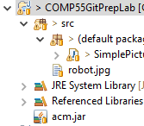Those signs that you see to the left of the project are letting you know that git believes that these files have changed. When files have changed, git wants to give them a new version number. To give or to save these files so that git can reference them in the future, you’ll want to do what’s called **commit**. To commit the files, simply right click on the project and select *Team->Commit*. That may open up a **Git Staging View**, which will look something like this

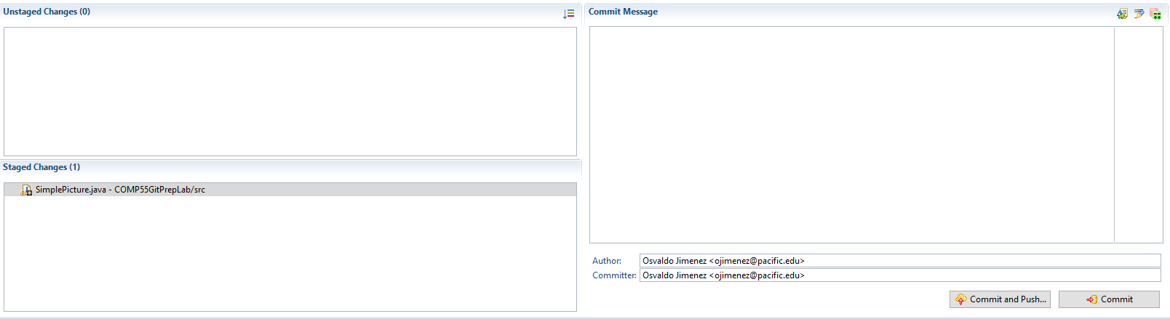

If you look, **staged** changes are files that git has identified as needing to be updated once you click the commit button, while **unstaged** changes are files that git has identified as being different than what’s on the server, but will not be updated after clicking commit. *You need to be careful of what you decide to put in staged changes versus unstaged changes.* When you try to commit, git looks at all files in your current directory to see what is new or what has changed. Anything it doesn’t know what to do will be put in the unstaged changes area.

In the picture above, the right area is the commit message, where you’ll want to write a short message that outlines what changes you made, in this case you can simply put something like, Changed the text to reflect final assignment. *Make sure the author/committer has the name and email that you stored in your preferences settings*. Finally near the bottom right of the image you’ll find two buttons: ***Commit and Push*** and ***Commit***. In this situation, I’m going to ask you to simply click **Commit and Push**, which not only saves a new version of your project (**commit**), but also sends your changes over to github.com (**push**). Sometimes you may just want to commit without sending all the changes to the server yet. We’ll talk about that in the git lab in the future. For now just click ***Commit and Push***. After clicking, you’ll get a dialog box where you can click OK.

## Step-13

Once you completed the steps and push, then I will know that you have completed the tutorial. To check yourself go to **github.com** and click on the repository file to see the changes that were made. If github.com has the change you pushed that’s part of the credit. The other part of the credit will come from the settings. In github.com you can go to your repository and click on the **commits** label in the upper left.

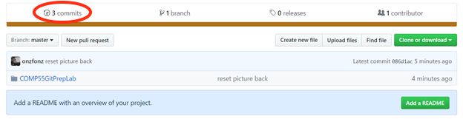

When you do that, you’ll see a list of the changes that you’ve made to the project. You should see a commit that has your picture and name on it at the top.

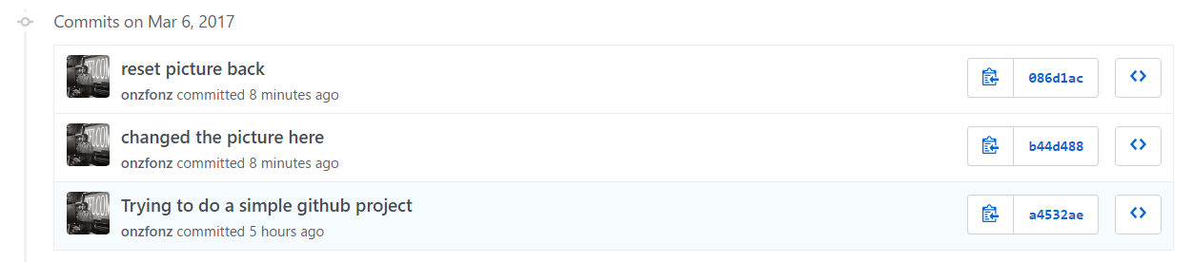

Click on the text that you made for your particular one to see the changes that you committed and how your commit changed the file, which you can immediately identify. If you see your custom picture and your name or id, then you’ll get the rest of the credit. If you don’t, then simply make an additional change to one of the files (adding a line or a space) while editing the user preferences outlined earlier in this lab. There’s no need to upload anything to canvas as all your changes will be stored on github. Hooray!

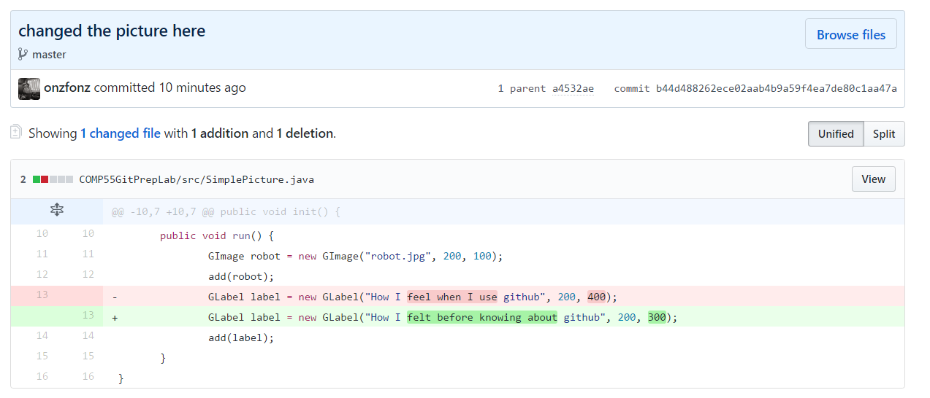

That’s it for now! We’ll do more with git in the future, but this is just meant to get you ready for when we start coding, which you should not do yet, since I have more code to give you to help you move along in the project, work on designing and coming up with classes and methods and the rest of your system design project instead!